**BARBADOS WRESTLING ASSOCIATION**

**Secretariat: Barbados Olympic Association Inc.**

**Sir Garfield Sobers Complex, Wildey, St. Michael, Barbados** 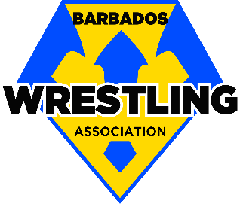

June 01, 2018

**INIVITATION-LETTER**

Dear Regional and International friends,

The **Barbados Wrestling Association** is honoured to invite all Athletes (juniors and seniors), Coaches, and Delegates to participate in the **Sport Tourism “BARBADOS BEACH WRESTLING CUP 3”** at the Pirates Cove Beach, Bridgetown Barbados on **Sunday, November 4th, 2018** with eliminations beginning at 10am and finals at 2pm.

Beach wrestling sport is gaining popularity throughout the world and will be one of the featured sports in the 2019 World Beach Games in San Diego California. This sport has been selected by Barbados Olympic Association Inc. Beach Games committee to be one of the main sports at its 2018 BiiG (Barbados Olympic Association Independence Invitation Games) in November.

This year we will include Beach Belt wrestling in the Beach segment on November 04, 2018 and for the first time Freestyle Wrestling on 3rd of November, 2018 at the said venue in the restaurant area.

In addition to seniors, there will be have over one hundreds kids between the ages of 5 and 14 from our Grassroots program who will be showcasing their wrestling skills. Elite Beach and traditional referee **Russell “Rusty” Davidson** USA Wrestling of Albuquerque, New Mexico, USA will be in attendance.

We welcome your support in helping us to promote and elevate the sport of beach wrestling and would be a motive of great satisfaction for the Barbados public to be able to welcome such distinguished representatives of combat sports in our region and internationally for weekend of competitive action and fun memories.

Yours Sincerely,

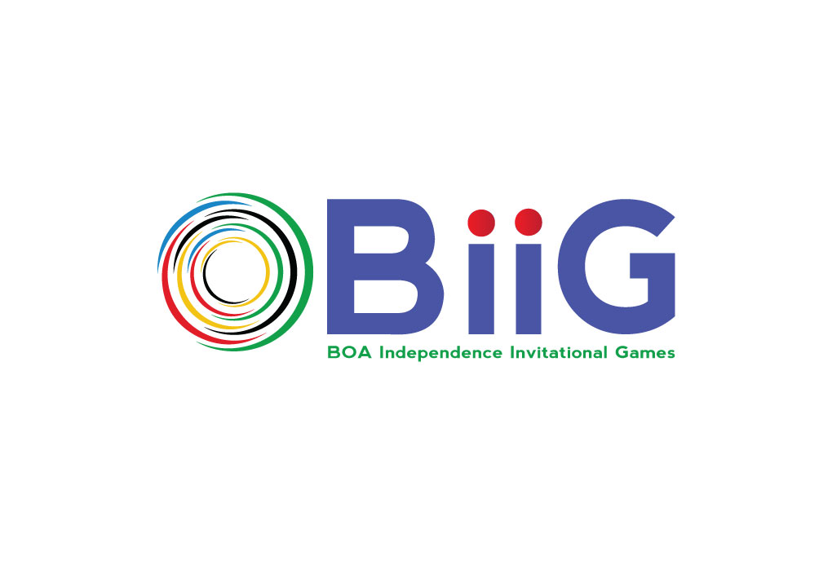

ROLLNS L. ALLEYNE

President

**barbadoswrestling@gmail.com**

**bar@united-world-wrestling.org**

**246 283 4526**